The Vegan Boom and My Month on an Animal-Free Diet

Life without meat or dairy? Can it offer more than social isolation, endless chopping and inedible fake cheese?
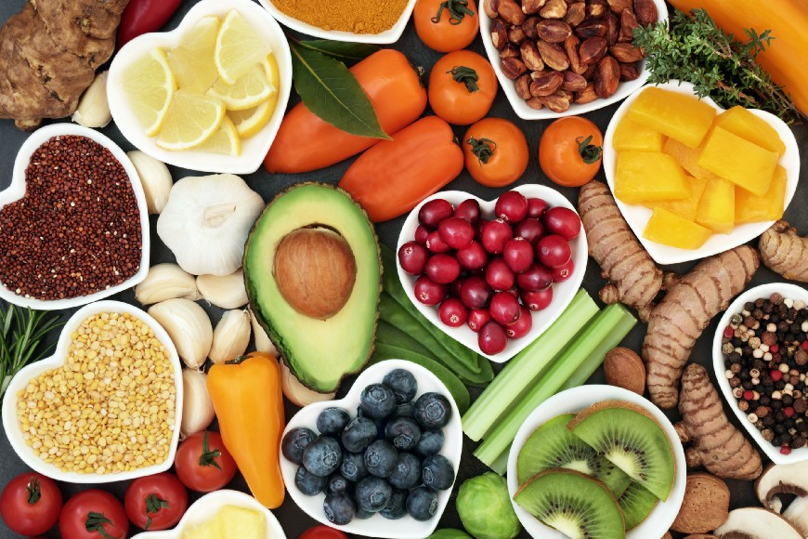
By Henry Mance
Corey Harrower wants to make one thing clear: “I’m a vegan but not an asshole.” Vegans — people who don’t eat or even use any animal products — have a reputation for evangelising. Harrower, a 35-year-old former professional dancer originally from Vermont, wants to change that. He says that he has never directly tried to convert anybody. “I don’t think anyone likes people who tell them what to eat.”
But Harrower, who turned vegan about five years ago, may have found a more ingenious way to spread the message. ROLI, the London-based music technology company where he is chief people officer, offers all its employees a free lunch every day. At his instigation, the meal is always vegetarian — and generally vegan. Around 120 employees now eat meat-free lunches; some take leftovers home for dinner.
“When we first launched the programme [five years ago], people were like, can we have a BBQ or some meat in the corner? Eventually, people just started applauding,” he says, adding that he personally still salivates at the thought of a steak.
ROLI’s free lunch illustrates why veganism is making waves. It’s not just demand, part of a trend towards caring about what we eat. It’s not just the backing of celebrities like Beyoncé and Lewis Hamilton. The real difference is that the pain is being taken out of vegan eating. Veganism once had austere, even monastic, connotations; its adherents were thin, gaunt types who seemed to reject not just animal products but modern society as a whole. Now, on both sides of the Atlantic, supermarkets and restaurants — from Waitrose to Shake Shack — are stocking up on plant-based options. Holland & Barrett, the British health-food chain, plans to open vegan-only stores. Quorn, the fake meat brand, is aiming to increase its revenues fivefold to £1bn within a decade.
“In the past three to five years, I’ve seen more changes in the availability and variety of vegan food than I have seen in the 30 years prior,” says Dawn Carr, a campaigner at animal rights group People for the Ethical Treatment of Animals (Peta). “We’ve moved beyond falafel and fruit salad.”
There’s more to come. US meat giants such as Perdue and Tyson have invested in plant-based alternatives. One of those, Beyond Meat, has become hugely popular in the US. It was due to start selling its burgers in Tesco supermarkets from August; the launch has been pushed back because the company cannot keep up with existing demand.
In 2018, trying to persuade someone to change their diet is still a recipe for conflict. But meatless meals may have passed a tipping point — in many scenarios, they are the lowest common dominator, the easiest option. The number of vegans in the UK has quadrupled in the past four years, to about 600,000, according to the Vegan Society. Once a vegan going to a dinner party would do well to be offered beans on toast. Today, there’s a chance that the whole menu will be turned into something everyone can eat — a chilli non carne or a butternut squash curry.
Veganism isn’t just winning converts; it’s helping to shape a much larger group, labelled “flexitarians” or “reducetarians”, who are trying to cut down on meat and dairy. “If you give me a sausage roll, I’ll eat it. But you won’t find bacon in my fridge,” as a flexitarian colleague puts it. More than a quarter of evening meals in the UK now have no meat, according to consumer research company Kantar Worldpanel. Dairy UK, an industry group, has warned that “younger generations do not always see dairy as being an essential part of their diet”. Alpro, one of the biggest brands of milk substitutes, says that one in four UK households now buys its products. “The number of diehard vegans is relatively small.
Our growth is definitely being driven by meat-reducers,” says Chloe Graves, buyer for Waitrose’s vegan and vegetarian ranges.
In the office environment, Harrower argues that a meat-free menu can strengthen the sense of community because almost anyone can eat the same dish. “Hopefully, we can do it in a non-confrontational way. ‘We made something really nice for you. Do you want it? If you don’t, there’s a fried chicken place over the road.’” On the day I visit ROLI’s office in north-east London, the free offering is an artichoke and broccoli salad, with rye-bread croutons and basil oil. You would pay good money for it.
Such changes are probably easier at companies like ROLI, where staff have never known an alternative. (When Google tried to turn two of its canteens vegetarian once a week, the workers revolted.) It probably helps too if the guinea pigs are younger.
Young people will follow this diet for their entire lives . . . Veganism has got the Instagram generation. —Shane Holland, Slow Food in the UK
Veganism’s youth is its strength or its weakness, depending on who you ask. More than half of British vegans are under 35. Shane Holland, chair of Slow Food in the UK, which campaigns for better-quality ingredients, contrasts veganism with the embrace of quick Italian food, which was driven by an older demographic watching Jamie Oliver on TV. “I think this will probably be much longer-lived,” he says. “Young people will follow this diet for their entire lives . . . Veganism has got the Instagram generation.”
Others argue that, because vegans are often recent converts, they could revert to meat eating. Celebrities including Beyoncé and Serena Williams have talked about veganism as a temporary diet. Some vegans report health problems; others become frustrated with all the chopping and thought the diet requires.
Is plant-based eating really here to stay?

For a month this summer, I went vegan. I’d been vegetarian for three years but the thought of giving up dairy and eggs was unappealing. I relied on cheesy pasta, halloumi and omelettes.
Yet I have to admit that veganism is possibly a more logical position than vegetarianism. First, you can argue that humans are justified in eating meat, because other animals do too. But no animals — or virtually none — regularly drink the milk of other species. Indeed, two-thirds of humans struggle to digest milk, because their intestines cease to produce sufficient quantities of the necessary enzyme, lactase. (Lactose intolerance varies sharply by ethnic group, affecting more than 90 per cent of East Asians and fewer than 5 per cent of northern Europeans.)
Second, if you are a vegetarian because you object to killing animals for food, then eggs and milk are bad news. Mass-producing eggs involves killing male chicks (generally by throwing them in a grinder) because they are of no use for subsequent production. Dairy cows have to be regularly pregnant to produce milk; nearly all their male calves are killed for meat, usually within two years, for the same reason.
Indeed, when the term “vegetarian” was first introduced to a wide audience in the 1840s, it appears to have referred to a vegan diet. A man from Liverpool wrote into a society newsletter, asking what to use “for animal food — for tea, coffee, butter, eggs, milk, &c”. He was told, among other things: “For pie-crusts, use mashed potatoes, or yeast, instead of butter or lard.”
Veganism had a new lease of life in the 1970s as part of the animal rights movement. Since then, it has been occasionally branded as a “plant-based diet”, which, to me at least, sounds boringly bureaucratic. The breakthroughs have been gradual. Linda McCartney launched frozen meals in 1991. Coffee chains started rolling out soya and almond milk a decade ago. But the people developing other vegan products were still relative amateurs. “They weren’t food scientists or professional food developers,” said Jennifer Pardoe, a consultant in plant-based foods.
For Pardoe, the turning point was Coyo, a dairy-free yoghurt made almost entirely of coconut milk, which launched in Australia in 2010. “Suddenly there was a plant-based product that was absolutely beautiful and things just spiralled,” she says. Even so, as of 2016, veganism accounted for only about 1 per cent of the UK and US populations.
For my own experiment, I didn’t do much preparation. I knew that I was embracing an ideological path that would separate me from my children, while bringing me benefits that were at best uncertain. It was like becoming a Brexiter. “Is humble pie vegan?” my wife helpfully wrote on the fridge.
Vegan advocates have tried to make the switch easy by providing a week of simple vegan menus. Gwyneth Paltrow, the actor-turned-lifestyle guru, does the same — seven days of different recipes. Show me a person who wants to eat different things every day for breakfast and I will show you a psychopath. Especially when one of Paltrow’s breakfast suggestions is “Leftover Quinoa”.
Mealtimes became a chore. I couldn’t relax around food. I ordered a vegan burger at a pub and it came with non-vegan coleslaw
What I really needed was simplicity. I turned to the lists of brands that you can eat (Shreddies are fine but Alpen contains milk) and things you should probably eat (Marmite has vitamin B12; peas and broccoli have protein).
Amazingly, my local convenience store turned out to have 18 different types of non-dairy “milk” (yes, it is in north London). The European Court of Justice ruled last year that plant-based products cannot be sold as “milk” or “cheese”, although almond milk and coconut milk are exceptions. One of these — Swedish oat drink Oatly — used to challenge shoppers to give up cow’s milk for 72 hours. After that, it argued, you would become used to the taste. There is something to this. I never became fond of almond milk, but soya milk and oat milk soon tasted decent enough.
The food critic Alan Richman once divided vegan restaurant food into three categories: Worth Ordering Again; Just Plain Bad; and Bad Beyond Belief. I would divide things differently: Everyone Should Eat This; Worse But Acceptable; and Let’s Not Even Pretend. In the Everyone Should Eat This category is much Asian cuisine. In Worse But Acceptable, I would put sweetened soya milk, Linda McCartney burgers, tofu-based pesto and vegan dark chocolate — all of which you quickly get used to. The final, saddest category, Let’s Not Even Pretend, contains anything involving cheese, including vegan pizzas.
Cheese is the hardest challenge for many vegans. The available substitutes — using coconut, yeast and nuts — fail to recreate the magic. “We’re talking about a completely different set of proteins, and they wouldn’t tend to support the growth of the same type of bacteria,” says Paul Thomas, a (real) cheesemaking instructor. “We’re only beginning to get to grips with the complexity of what’s happening in cheese that we’ve been making for thousands of years.”
Overall, in a city like London, becoming a vegetarian compares to giving up your car and relying solely on public transport. You avoid as much hassle as you incur. Becoming a vegan, however, is like committing to solely walking or cycling. Quite a lot of things become an inconvenience; a few are completely out of reach.
If you are bored of the sandwich selection in Pret A Manger, imagine how you would feel if there were only one or two options. In restaurants, you are still often lucky to get that. Anthony Bourdain, the late chef, implicitly identified the fundamental problem facing vegans: “I don’t care what they tell you they’re putting or not putting in your food at your favourite restaurant, chances are you’re eating a ton of butter.”

Food is less faddish than we sometimes assume. Ingredients — such as the acai berry — do come and go. Clean eating has been exposed as flimsy. But the fundamental shifts stick around. Although the Atkins diet died shortly after its founder did in 2003, its low-carbohydrate philosophy lives on in the form of the gluten-free and Paleo diets.
Veganism has three main benefits: less animal cruelty; reduced environmental impact; and, potentially, improved health. Animal rights activists argue that social media has allowed them to communicate the wrongs of factory farming like never before. “We have YouTube and Facebook and Twitter and all of these ways to get images in front of people’s eyes. You can’t unsee it,” says Peta’s Dawn Carr.
For me, there are two potential roadblocks on veganism’s path to mass take-up. First, the diet may not change the big picture. Will the reduced consumption of meat and dairy due to veganism be outweighed by increased consumption of the same products by people on low-carb regimes?
In the EU, there have been modest declines in the amount of beef, pork and lamb eaten per person since 2000. But the amount of chicken eaten has shot up. (The US has more vegan products than the UK but also consumes more meat per capita — which country has further to travel?)
The second risk is that another priority comes along. People will always care about their food and health but this could be channelled into buying local produce or ethical meat instead. A recent industry report in the UK argued that veganism was not a fad but that many converts were not ideologically committed to it: “Targeting with appropriate health messaging could turn the tide.” A Harvard professor last month described coconut oil, with its high saturated-fat content, as “pure poison”. Veganism is starting from such a low base that it needs to keep up high momentum.
As my month of veganism wore on, I didn’t feel more lethargic or more energetic, I didn’t lose weight, I didn’t feel like a social outcast. And I didn’t have to endure any conversations about where I got my protein from. But I did struggle to take the same pleasure in food that I had before. Mealtimes became, frankly, a chore. I couldn’t relax around food. I ordered a vegan burger at a pub, and it arrived with non-vegan coleslaw. To continue the Brexiter analogy: I was occasionally forced to soften my red lines.
One vegan cookbook advises carrying snacks everywhere in case you can’t find the right food; another says you may find it easier to consume two meals a day — “a large breakfast and an early supper”. You need a strong commitment to embrace this kind of hassle. Only when I went to Wulf & Lamb, a well-reviewed vegan café near London’s Sloane Square, did I feel a sense of liberation.
“If veganism is going to survive or to win or whatever, it’s got to have more options, to be more creative. Let’s hold ourselves to a higher standard,” says Harrower of ROLI. “It’s going to be a slow burn. We’ve got tens of thousands of years of history to go against.”
Personally, I’m up against 35 years of dairy eating and I feel it may be easier to wait another five. But, two weeks after the experiment was meant to end, I am still basically vegan. Maybe new habits die hard.

